**The Great Gatsby**

**Mastery and Retrieval Revision Booklet**

**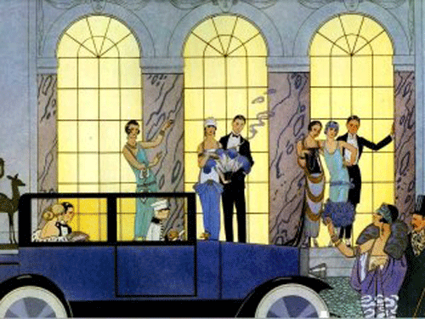**

What to do?

In this booklet you have essay plans for two/three questions for character, plot, theme and setting.

1. Read through the booklet and highlight/ annotate key ideas so that you know how to tackle the questions.
2. Select one question to answer under timed exam condition: you have 1 HOUR.
3. You need to submit your essay in your first lesson back after the Summer Holidays.

**Questions on Character**

Example questions:

Choose a novel **or** short story in which the method of narration is important.

Outline briefly the writer’s **method of narration** and explain why you feel this method makes such a major contribution to your understanding of the text as a whole.

Choose a **novel** in which betrayal or **deception** or naivety plays an important part.

Show how the writer explores this idea in a way which adds to your understanding of the central concern(s) of the text.

Choose a **novel** in which loyalty or bravery or **trust** plays an important part.

Show how the writer explores the idea in a way which adds to your understanding of the central concern(s) of the text.

All these examples relate to:

* Nick as unreliable narrator
* Mystery around Gatsby
* Gatsby’s illegal dealings
* Gatsby’s falseness

Choose a **novel** in which a central character is flawed but remains an admirable figure.

Show how the writer makes you aware of these aspects of personality and discuss how this feature of characterisation enhances your appreciation of the text as a whole.

This example relates to:

* Mystery around Gatsby
* Gatsby’s illegal dealings
* Gatsby’s falseness
* Gatsby’s end

Nick as unreliable narrator

Although he appears a credible source, we are forced to doubt some of what Nick relates:

“I’m inclined to reserve all judgements.”

“I am one of the few honest people I have ever known.”

“I was privy to the secret grief”

Nick is shown to be impartial, open minded and a good listener.

Nick does not approve of the nouveau riche lifestyle.

“Gatsby, who represented everything for which I have an unaffected scorn.”

“I disapproved of him from beginning to end.”

Nick’s lifestyle, the parties he attends and dislike he shows suggest he is not to be trusted.

Nick admits that he “**feigned sleep**” when people confided in him, he views Gatsby’s life with “**unaffected scorn**” and he’s “**disgusted”** by Tom and Daisy’s marriage.

His overall summary of Gatsby shows Nick cannot help but admire him. He recognises Gatsby’s motives as honest.

“You’re worth the whole damn bunch put together.”

Mystery around Gatsby

Fitzgerald surrounds Gatsby in mystery. This suggests we never know the real Gatsby and that this society does not care about reality- only wealth.

“Somebody told me they thought he killed a man once.”

It’s more that he was a German spy during the war.”

“Sometimes they came and went without having met Gatsby at all.”

Gatsby’s illegal dealings

Gatsby appears to be a charming socialite but behind all the wealth and parties his money is made illegally.

“Meyer Wolfsheim- he’s the man who fixed the World series back in 1919.”

(Tom) “I picked him for a bootlegger the first time I saw him.”

Gatsby’s falseness

As a member of the nouveau riche Gatsby uses money to show off. This money adds to his false persona and hides the real Gatsby.

“Gatsby, in a white flannel suit, silver shirt and gold-coloured tie, hurried in.”

“His bedroom was the simplest room of all — except where the dresser was garnished with a toilet set of pure dull gold.”

Despite all the wealth and ostentation, some of Gatsby’s persona is real. The books in his library are all real and although he may not be an oxford graduate he spent some time there. He is a man of contradictions.

“I was brought up in America but educated at Oxford…”

**tn00332_Questions on Plot**

Example Questions

Choose a novel **or** short story in which there is a moment of significance for one of the characters.

Explain briefly what the significant moment is and discuss, with reference to appropriate

techniques, its significance to the text as a whole.

Choose a **novel** in which one incident acts as a turning point in your understanding of a central character.

Describe the incident and discuss how it influences your understanding of the character and of the novel as a whole.

This question relates to:

* Gatsby’s falseness
* Weather
* Relationship with Daisy
* Gatsby’s symbolism

The turning point

A question relating to turning point needs to focus on Gatsby’s reunion with Daisy.

Choose a novel in which the opening establishes a central idea or theme of the novel.

This question relates to:

* Nick as unreliable narrator
* West Egg/ East Egg setting
* Gatsby’s symbolism

The opening

The opening of the novel introduces Nick as narrator, provides the setting and describes Gatsby’s green light.

Choose a novel **or** short story which has a satisfying ending.

Discuss to what extent the ending provides a successful conclusion to the text as a whole.

The conclusion

The conclusion highlights key themes, Daisy’s falseness and Gatsby’s true character.

This question relates to:

* Nick as narrator
* Ending
* Symbolism (green light)

The ending

As the novel ends we see Daisy’s true character and how Gatsby is remembered in death.

Daisy’s departure shows that she never truly loved Gatsby. Behind all the wealth she is false and frivolous.

“I called up Daisy half an hour after we found him, called her instinctively and without hesitation. But she and Tom had gone away early that afternoon, and taken baggage with them.”

After all the glamorous parties, Gatsby is quickly forgotten after his death. This also highlights the selfish nature of this society.

“Gatsby’s house was still and empty when I left”

“He had waited five years... so that he could “come over” some afternoon to a stranger’s garden.”

“I don’t think he had ever really believed in its existence before.”

Relationship with Daisy

As we learn through the novel, Gatsby has fashioned this entire lavish lifestyle in a bid to rekindle his love with Daisy. This highlights the romantic hope and desire within Gatsby but also his inability to accept that time has passed.

Daisy’s daughter provides proof of Gatsby’s inability to stop the passage of time.

Weather

The weather during Gatsby’s rekindled relationship with Daisy signifies mood.

When Gatsby and Daisy first meet, the rain adds depression and melancholy to the scene. However, as their love reawakens the sun comes out.

The oppressive heat hints at the claustrophobic tension, which will only escalate.

“ the sun shone again….twinkle bells of sunshine”

“Some weather!

…Hot! …Hot! …Hot!”

**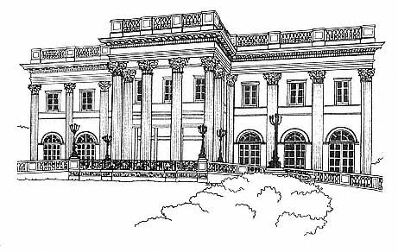Questions on Setting**

Example Questions

This example relates to:

* West Egg
* East Egg
* Gatsby’s falseness
* Valley of Ashes

Choose a **novel** in which a character is influenced by a particular location or setting.

Explain how the character is influenced by the location or setting and discuss how this enhances your understanding of the text as a whole.

West Egg

Gatsby represents the nouveau riche; he has found wealth very quickly and wants to show it off. Gatsby’s house is large and impressive but, significantly, a replica, not a genuine old house.

“The one on the right was a colossal affair…a factual imitation of some Hotel de Ville in Normandy…”

“In his blue gardens men and girls came and went like moths among the whisperings and the champagne and the stars.”

East Egg

“The white palaces of fashionable East Egg glittered alone the water.”

In contrast, East Egg is home to the ‘old money’. Society here has inherited their money and there is a feeling superiority and arrogance. Their homes are genuine even if their values are corrupt.

The Valley of Ashes

The Valley of Ashes is a symbol of desolation and poverty. It exemplifies the failure of the American Dream where the rich get richer and the poor only become poorer.It is a place of poverty that is a dumping ground for all the waste produced by the city. It is an ugly by-product of consumerism forgotten by the wealthy Egg communities.

Valley of Ashes

“ …a fantastic farm where ashes grow like wheat into ridges and hills and grotesque gardens.”

They are like the wasteland, unnatural and decaying. They are a parody of an uncaring God. They watch but do not see. The eyes symbolise what remains of the image of God to the poor in America- he is absent to them.

“ Over the ashheaps the giant eyes of Doctor T.J. Eckleburg kept their vigil.”

**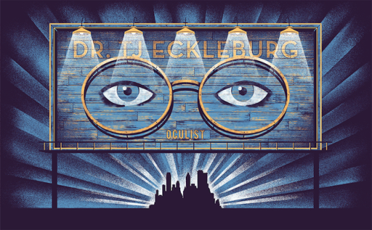Questions on Theme**

Example Questions

Choose a **novel** in which the death of a character clarifies an important **theme** in the text.

Show how this **theme** is explored in the novel as a whole and discuss how the death of the character clarifies the theme.

Choose a **novel** in which **envy** or malice or cruelty plays a significant part.

Explain how the writer makes you aware of this aspect of the text and discuss how the writer’s exploration of it enhances your understanding of the text as a whole.

Choose a **novel** or **short story** in which there is a character who is not only realistic as a person but who has **symbolic** significance in the text as a whole.

Show how the writer makes you aware of both aspects of the character.

This example relates to:

* Symbolism
* Gatsby’s falseness
* Relation with Daisy
* Ending
* Setting

Symbolism

Gatsby is the symbol of the American dream – he has come from poor beginnings and found fame and fortune. However the **theme of the novel is the corruption of the American dream**: in the 1920s, the American Dream has, in the pursuit of happiness, degenerated into a quest for mere wealth.

“His parents were shiftless and unsuccessful farm people- his imagination had never really accepted them as his parents at all.”

(Tom) “I suppose the latest thing is to sit back and let Mr. Nobody from Nowhere make love to your wife.”

“Can’t repeat the past?...Why of course you can!”

“Gatsby believed in the green light.”

By looking at Daisy’s dock, Gatsby was looking East. The green light, like America itself, was once a symbol of hope, but the original ideals of the American Dream have deteriorated into the pursuit of wealth. Gatsby represents this hope to return the past but it is a false dream; as we see in Daisy’s actions, the world is now a false and shallow place and Gatsby is unable to live within it.