Welcome to A level Religious Studies Taster Tasks 2024

Title of Tasks | Purpose of Task: | Time to be taken | Outcome Expected
Task 1: Ethics | Enquiry into ethical concepts.  Develop understanding of absolute and relative morality.  Applying examples. | 2 hours | 500-800 words.
Task 2: Philosophy | Understanding of the contrasting Philosophies of Plato and Aristotle. | 5 hours | Detailed notes and labelled diagrams (see below for details)
Task 3: Christianity | To gain a sound understanding of the basic beliefs of Christianity | 2 hours | Bullet point notes

Task 1: Ethics
Scenario: I’m on school lunch duty and I see and hear a boy saying nasty things to another boy while they’re eating their shepherd’s pie.
Questions:
- Why is it OK, and my duty, to tell him off for being unkind?
- Why is it not OK for me to tell him off for eating meat (if I’m vegetarian)?
And then:
- Which, if any, of our beliefs are ‘just a matter of personal preference’ and which, if any, refer to some kind of absolute fact? Explain your reasons fully with examples if possible.

- Should we leave others to their ‘personal preference’ in matters of religious belief, or are some religious beliefs right and others wrong in an absolute sense? Explain your reasons fully with examples if possible.

- Is there an ultimate truth, an absolute right and wrong, about religious truth claims? Explain your reasons fully with examples if possible.

- At what point, if any, does one culture have the right to tell another ‘you’re doing it wrong’ over matters of religion and ethics? Explain your reasons fully with examples if possible.

- To what extent, if at all, do people have an obligation to share their religious faith with others – or should we keep our beliefs to ourselves and try and respect the views of others even if we think they’ll miss out on going to heaven? Explain your reasons fully with examples if possible.

Task 2: Philosophy
Listen to the following two podcasts
https://thepanpsycast.com/panpsycast
- Episode 1 –Plato’s Cave
- Episode 2 –Aristotle’s Basic Philosophies

- Listen to both podcasts and take your own notes on the main ideas of Plato and Aristotle.

- Find a picture of Plato’s Cave like the one below and label it in as much detail as you can from listening to the podcast and your own research.

- Find a picture of Aristotle’s Four Causes like the one below and label it in as much detail as you can from listening to the podcast and your own research.

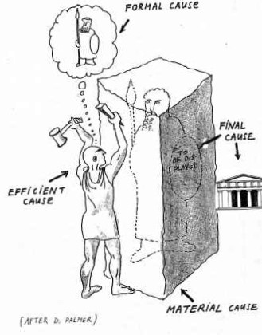
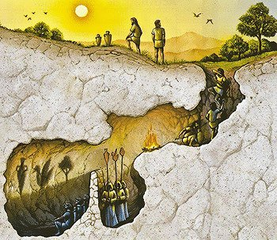

Task 3: Christianity
Many of you will have studied the religion of Christianity for GCSE.
You all need a basic understanding of Christianity for A-Level RS.
Read the information on the following website and take good notes on the questions below:
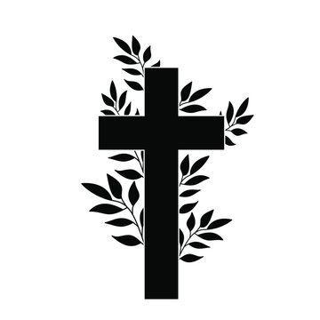
BBC - Religion: Christianity
- Explain the major Christian beliefs about God the Father, God the Son and God the Holy Spirit.
- What are Christian teachings on Original Sin?
- Why did Jesus have to die? What is God’s plan of Salvation according to Christians?
- There is a lot of information on this website. Explore other areas of Christianity that you have not studied before.

